**Initial Assessment**

|  |  |  |
| --- | --- | --- |
| **Presenting Symptom/Chief Complaint** | | |
| Patient is complaining of tiredness, apathy, depression, chilliness, feeling of heaviness, slight abdominal distention pain and heaviness in the leg with walking. | | |
| **Main Signs and Symptoms** | | |
| Patient feels heavy, tired all the time with puffiness at the leg around the ankle area at the end of the day, leg pain that create disturbances with sleep. | | |
| **Other Signs and Symptoms** | | |
| Tiredness, poor appetite, poor motivation, mood all the time down, pain in the leg at the end of the day, tongue pale, pulse week. | | |
| **TCM Diagnosis and Treatment (identified TCM disease, TCM differentiation of syndromes)** | | |
| Kidney yang deficiency KI Qi deficiency (deficiency of narrow) with blood QI stagnation. Spleen QI deficiency, dampness in the body. | | |
| **Treatment Principles and Strategies** | | |
| Tonification of the Ki and spleen resolving dampness. Tonification of kidney Yang energy, nourish the narrow and stimulate rising QI. | | |
| **Treatment Plan (Modalities; acupuncture, herbal, dietary, manual therapies), frequency and duration** | | |
| Acupuncture with preferable local joints, tonification method and direct Moxibition to raise the yang energy of the kidney every 2-3 days. Spleen QI tonification with acupuncture, resolve dampness at the leg area. | | |
| **Any other Advice Given to Patients** | | |
| Local points SP 6; SP 8;SP9; bilaterally. ST36, SP6 with tonification and direct Moxibition to raise the Yang Qi. K6,K4, K3, bilaterally REN 3, REN 4, REN 6 with tonification and Moxibition.  Back joints UB 23(L,R) , UB58(L,R) , EX 21 at the level of L1-L4, S1-S4; UB 40 to resolve the dampness of the area.  UB 60;62;ST43; ST44;ST 42(bilaterally with sedation of the points at the acute stage. Direct Moxibition to raise the QI and Yang QI of the kidney and spleen. | | |
| **Practitioner:** | **Date:** | **Signature:** |

**Daily Charting____________________________________Patient Name:_________________________**

**Date:_______________**

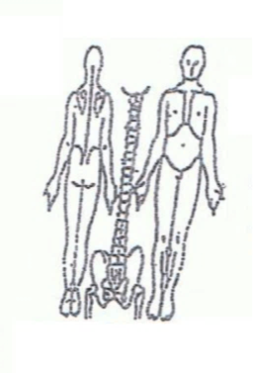 **Working Diagnosis:** Painful obstruction syndrome of the leg with QI and blood stagnation dampness with **underlying** Ki and spleen Qi and Yang Qi deficiency.

S:Patient is complaining of tiredness , lack of motivation , low self-esteem, pain ???? in all lower part of the body, heaviness, oedema at the ankle areas.

O:

Treatment (P) Acupuncture with warm needles

(A)

**Date:________________**

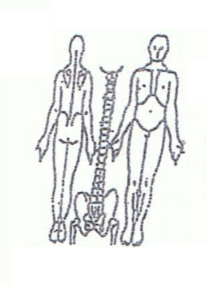 **Working Diagnosis:**

S: Patient have a poor sleep and memory, low mood and lack of motivation. Tired all the time, especially at the end of the day with pain at the leg around the knee and ankle.

O:

Treatment (P) Acupuncture with tonification and direct Moxibition -1 hour

according to plan.

(A)

**Date:________________**

**Working Diagnosis:**

S: Patient sleeps better, better motivation and appetite. Movement with less pain in the leg. ROM, energy level.

O:

Treatment (P) Acupuncture with warm needle, tonification for 45-60 minutes. Du 20

tonification with H7 combination

(A)

**Date:________________**

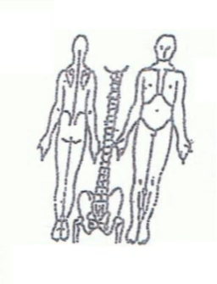**Working Diagnosis:**

S: Sleep better , level of energy

O: pain at the legs , oedema around the ankles, feet area

Treatment (P) Acupuncture + Moxibition - 1 hour according to protocol.

(A)

Date:________________

**Working Diagnosis:**

S: Patient has N sleep . No oedema at the leg, feet. No pain with movement. No constipation. N appetite. N energy level . N ROM.

O:

Treatment (P) Acupuncture with Moxibition . Core strengthening.

(A)